**Han Zhang u7235649**

**Q1.**

1. Hue
2. The name of the color, like red, blue, green, etc. Colors with different hues have different wavelengths.
3. Not a linear filter. It is not all linear operations since it contains modulo operation.
4. (a) The image will be lighter, which means in the histogram the values are further to the right.

(b) About 0.375.

(c) For M1, all pixels will have the same effect. But for M2, pixels which values between 30 to 50 will be darker than the other pixels.

**Q2.**

1. 1 0 -6

0 1 -8

0 0 1

1. Red square:

0 -27 -20

2 0 -29

0 3 0

Blue square:

0 -22 -40

3 0 -31

4 3 0

Performs: fitting the borders (lines) diagonal in top left to bottom right direction.

1. 16 0 12

0 0 0

12 0 9

**Q3.**

1. N is about 6.
2. Step 1: For grayscale images, compute:

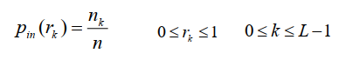

L: total number of gray levels;

nk: number of pixels with certain gray value rk

n: total number of pixels in the image.

Step 2: Based on CDF, compute the transformation:

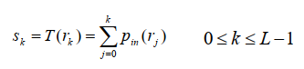

Step 3: Map the pixels with new values.

1. The contrast of the image will increase. Because after the histogram equalization the bright pixels will be brighter and the dark pixels will be darker.

**Q4.**

An ellipse is defiled by for parameters: x0, y0, a and b. Given a point (x, y), all possible ellipses will satisfy:

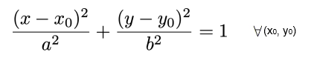

Step 1: For each white pixel at (x, y), vote an ellipse cone in param space.

Step 2: Find the parameter pairs with most votes.

Step 3: To calculate whether a pixel belongs to an ellipse or not and which ellipse it belongs to, for the voted parameter pairs, calculate the distance of the pixel to the ellipse the parameter pair defines. The more likely the pixel belongs to the ellipse, the smaller the distance is. If the distance is 0, it means this pixel belongs to the ellipse defined by this parameter pair.